BUSINESS REPORT – CREDIT CARD CUSTOMER ANALYSIS PROJECT

Submitted by: Goli Bhagyasri

TABLE OF CONTENTS

SNO | CONTENTS
1. | Business context
2. | Objective
3. | Data description
4. | Data Dictionary
5. | Data view
6. | Data shape
7. | Data missing values, Duplicates and Null values
8. | Statistical summary of the dataset
9. | Exploratory Data Analysis
10. | Univariate analysis of Avg_credit_limit
11. | Univariate analysis of Total_Credit_Cards
12. | Univariate analysis of Total_visits_bank
13. | Univariate analysis of Total_visits_online
14. | ECDF Plot
15. | Bivariate analysis
16. | Correlation by Heatmap
17. | Pair plot of numerical variables
18. | Scaling data
19. | K-means Clustering
20. | Elbow method
21. | Checking Silhouette Scores
22. | Hierarchical Clustering
23. | Computing Cophenetic Correlation
24. | Cluster Profiling and Comparison - K-means Clustering
25. | Cluster Profiling: Hierarchical Clustering
26. | display with highlight for max value per column
27. | K-means vs Hierarchical Clustering
28. | PCA for Visualization
29. | Final Recommendations

FIGURES USED IN THE REPORT:
Fig1. First five rows of data 1
Fig 2: Statistical summary
Figure 3: Univariate analysis of Avg_credit_limit:
Figure 4: Univariate analysis of Total credit cards
Figure 5: Univariate analysis of Total visits bank
Figure 6: Univariate analysis of Total visits online
Figure 6: ECDF plot
Figure 7: Correlation of numeric variables by Heatmap
Figure 8: Correlation of numeric variables by Pair plot
Figure 9: Scaled data
Figure 10: Selecting K with elbow method
Figure 10: elbow plot
Figure 11: Silhouette plot of K means clustering
Figure 12: Dendrogram of Various linkages for Cophenetic correlation
Figure 13: K-means Cluster profiling
Figure 14: K-means Cluster profiling using boxplots
Figure 15: K-means Hierarchical Cluster profiling for total credit cards
Figure 16: K-means Hierarchical Cluster profiling for total online visits
Figure 17: display with highlight for max value per column
Figure 18: display of max value per column using boxplot
Figure 19: K-means vs Hierarchical Clustering
Figure 20: PCA Using scatter plot

Business Context
All Life Bank wants to focus on its credit card customer base in the next financial year. They have been advised by their marketing research team, that the penetration in the market can be improved. Based on this input, the Marketing team proposes to run personalized campaigns to target new customers as well as upsell to existing customers. Another insight from the market research was that the customers perceive the support services of the back poorly. Based on this, the Operations team wants to upgrade the service delivery model, to ensure that customer queries are resolved faster. The Head of Marketing and Head of Delivery both decide to reach out to the Data Science team for help.
Objective
To identify different segments in the existing customers, based on their spending patterns as well as past interaction with the bank, using clustering algorithms, and provide recommendations to the bank on how to better market to and service these customers.
Data Description
The data provided is of various customers of a bank and their financial attributes like credit limit, the total number of credit cards the customer has, and different channels through which customers have contacted the bank for any queries (including visiting the bank, online, and through a call center).
Data Dictionary
- Sl_No: Primary key of the records
- Customer Key: Customer identification number
- Average Credit Limit: Average credit limit of each customer for all credit cards
- Total credit cards: Total number of credit cards possessed by the customer
- Total visits bank: Total number of visits that the customer made (yearly) personally to the bank
- Total visits online: Total number of visits or online logins made by the customer (yearly)
- Total calls made: Total number of calls made by the customer to the bank or its customer service department (yearly)

Data view:
It gives a view of the first five rows of the data.
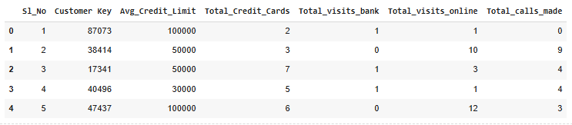
Fig1. First five rows of data 1
Data shape:
- The dataset has 660 rows and 7 columns
Data missing values, Duplicates and Null values:
- As seen previously, no columns have null values.
- And no columns have any duplicates or missing values.

Statistical summary of the dataset
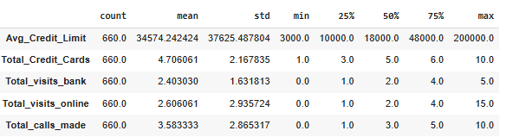
Fig 2: Statistical summary
Observations:
- Average credit limit range is high from 3000 to 2,00,000 with a median of 18000. Hence data is right skewed. Scaling can help reduce the variability before clustering
- Most customers visit the bank 1 to 3 times. This variable is tightly distributed, so it may have less impact unless normalized.
- Many customers barely use online services, but a few are highly active. Data is right skewed. This could be a strong differentiator in clustering.
- Possibility of Outliers in the data, which may impact the centroids.

Exploratory Data Analysis
Univariate analysis of Avg_credit_limit:
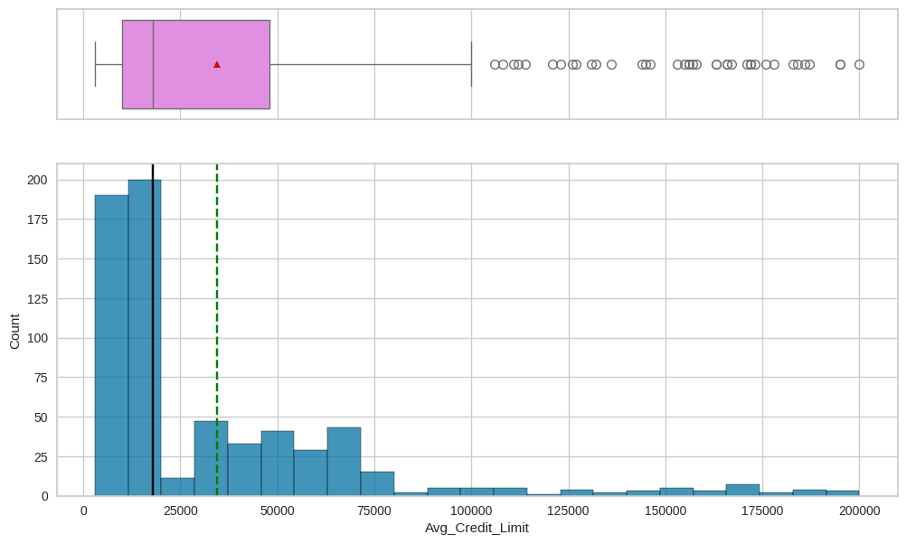
Figure 3: Univariate analysis of Avg_credit_limit:
- Data is heavily right skewed which means most of the customers have lesser credit limit.
- Outliers show many of the customers have higher credit limit indicating these customers can be segmented separately.
Univariate analysis of Total_Credit_Cards:
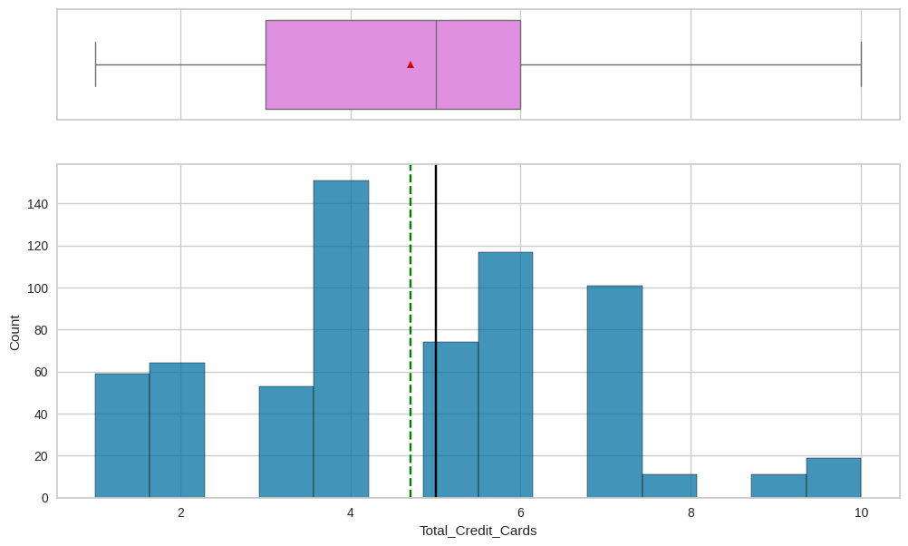
Figure 4: Univariate analysis of Total credit cards
- Data seems normally distributed with no outliers in it.
- This variable can be used to group customers into various segment like Few cards category(1-3), Moderate cards(4-6), Many cards(7+) which helps us easily observe and interpret the data.
Univariate analysis of Total_visits_bank:
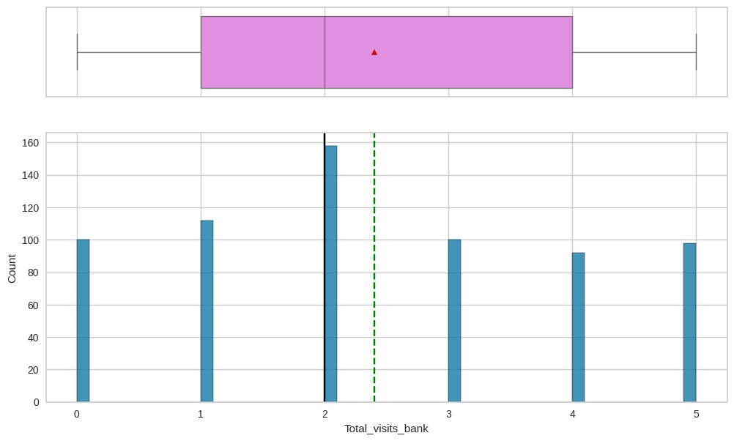
Figure 5: Univariate analysis of Total visits bank

- The above visual indicates most of the customers visit the bank atleast twice. So they so less exposure to the bank and heavy online presence
Univariate analysis of Total_visits_online:
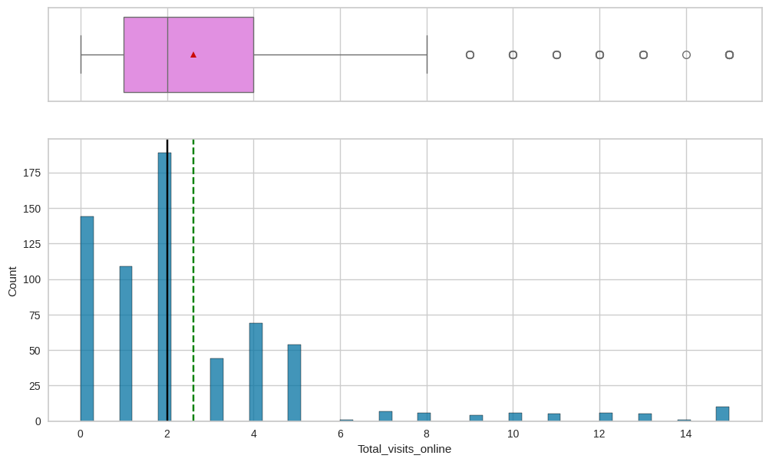
Figure 6: Univariate analysis of Total visits online
- The graph indicates most of the customers visit online at least 0-5 times.
- The outliers indicate some users who are more active online compared to others and they can be grouped separately.
ECDF Plot:
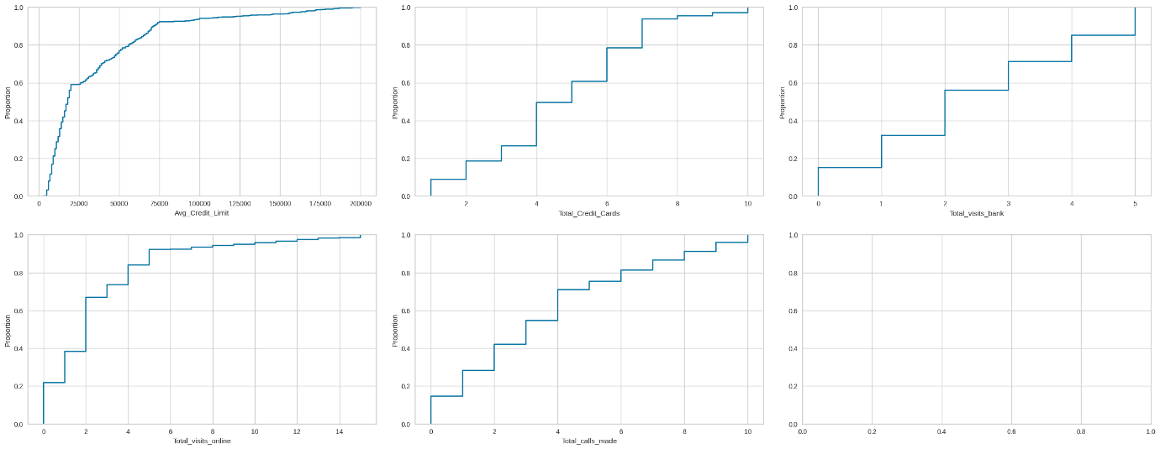
Figure 6: ECDF plot

Observations
- Avg credit limit shows a steep rise then fall. indicating strong eearly influence, high limits
- Total credit cards show a step wise increase, in which each additional card is adding the value.
- Gradual stepwise rise in total bank visits indicate a higher customer engagement.
- Total bank calls shows a similar pattern indicate most customers prefer online or offline service as they are dissatisfied with the call services.

Bivariate analysis:
Correlation by Heatmap:
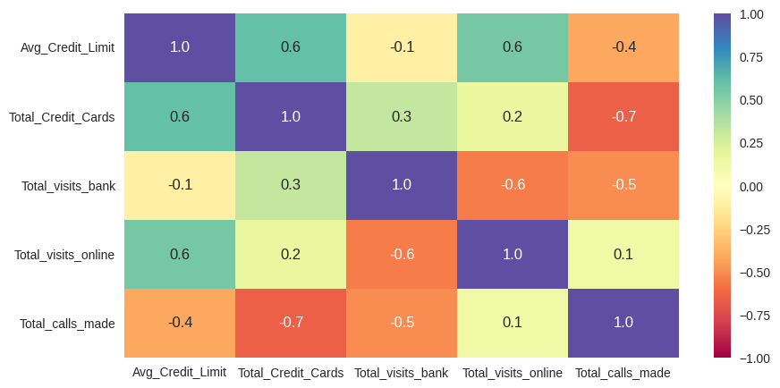
Figure 7: Correlation of numeric variables by Heatmap
Observations
- Avg credit limit shows and total credit cards show a 0.6 strong correlation. this means more cards mean higher credit limit.
- Total visits to the bank and total calls made online again show correlation of 0.5 possibily indicating service issues.
- There is a strong negative correlation with total credit cards and calls made, inidicating customers are mostly satisfied with the service.
- Visits to a bank online and offline also shows a negative correlation indicating the service is fulfilled online. This is a good point to focus for creating or enhancing online presence.
- Total calls made and visiting online also show stronger negative correlation indicating the more need for techno savy sources than offline services.

Pair plot of numerical variables:
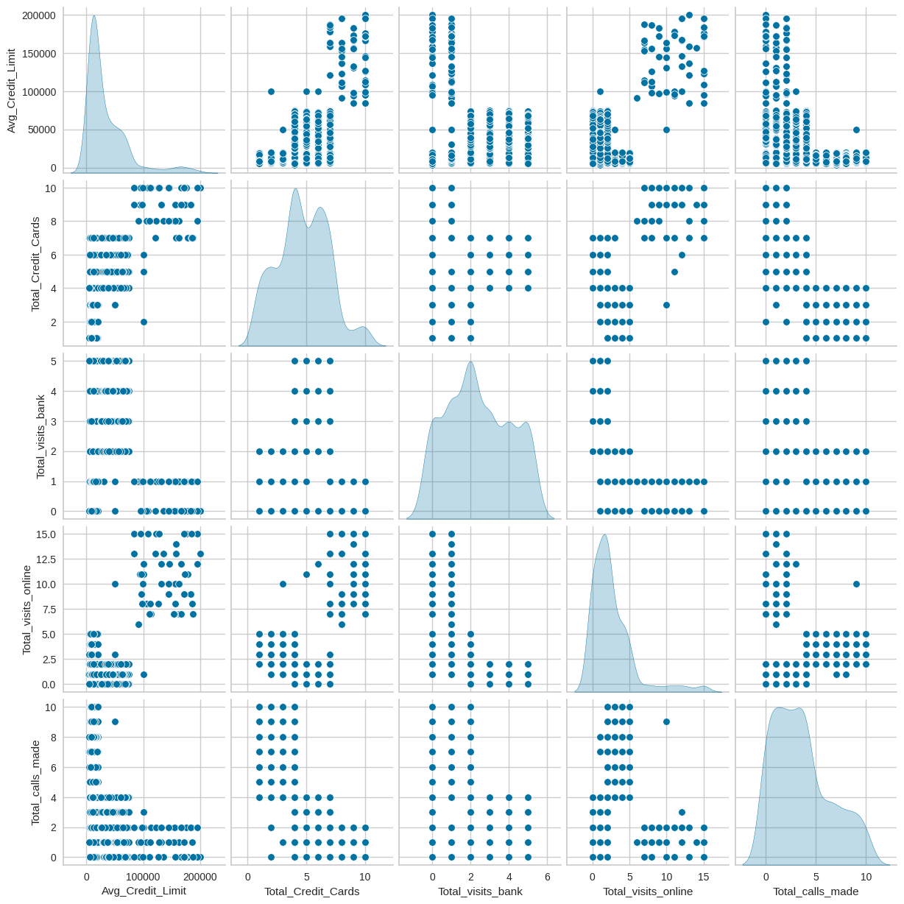
Figure 8: Correlation of numeric variables by Pair plot
Observations
A clear segmentation insight is -
- One segment with a cluster of digital users with high online visits and low calls
- Separate group with high call volumes and less tech savvy customers.
- A clustering strategy can be used by using these relationships to define behavioural clusters — e.g., “Digital Savvy,” “High Touch,” “Credit Heavy.”

Scaling data:
- We scale the data before proceeding for clustering.
- To remove bias from different units.
- Without scaling the large magnitude features dominate the distance calculations and clustering.
- Algorithms that rely on distance metrics like KMeans, Hierarchical, PCA with regularization, assume data is on a comparable scale. Scaling ensures each feature contributes equally.
- PCA (Principal Component Analysis) identifies directions of maximum variance. Without scaling, features with large magnitude dominate variance hence misleading the components.
- In our data, without scaling, clustering would have been driven almost entirely by credit limit.
- After scaling, all features contribute fairly, and you got meaningful clusters like call-dependent customers, branch users, digital premium users.

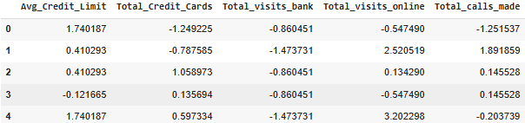
Figure 9: Scaled data

K-means Clustering:

K-Means is an unsupervised machine learning algorithm used for clustering (grouping similar data points).
The goal is to partition data into K clusters, where each point belongs to the cluster with the nearest centroid (average).
In this credit card project, KMeans grouped customers into segments like low-credit callers, branch users, and premium digital users.

Elbow method:
The Elbow Method helps us find the optimal number of clusters (K) for K-Means.
- K-Means tries to minimize the within-cluster variance (also called distortion or inertia).
- As K increases, distortion decreases (because more clusters = better fit).
- But after a certain point, adding more clusters gives only small improvements.
- The point where the curve bends like an “elbow” is the best K.
- Elbow point in our graph is at K = 3.

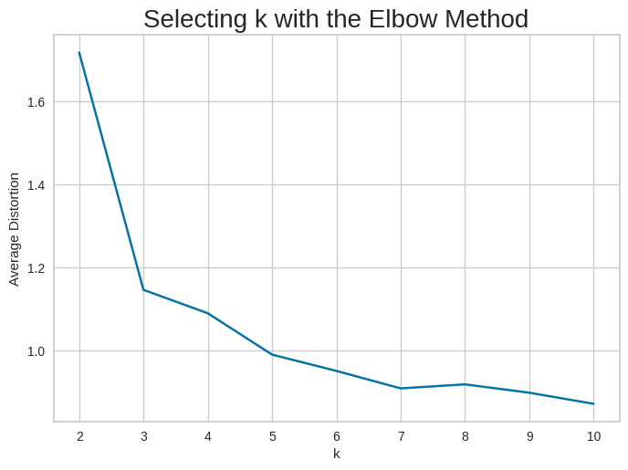
Figure 10: Selecting K with elbow method

Checking Silhouette Scores:

The Silhouette Score measures how well data points fit within their clusters.
Score Range -
- +1 : Perfect fit (point is well inside its own cluster, far from others).
- 0 : On the boundary between two clusters.
- -1 : Misclassified (closer to another cluster than its own).

For n_clusters = 2, the silhouette score is 0.5703183487340514)
For n_clusters = 3, the silhouette score is 0.5157182558881063)
For n_clusters = 4, the silhouette score is 0.3744071798973986)
For n_clusters = 5, the silhouette score is 0.27167502160723267)
For n_clusters = 6, the silhouette score is 0.24804756291576194)
For n_clusters = 7, the silhouette score is 0.24791254258020035)
For n_clusters = 8, the silhouette score is 0.22570382558070443)
For n_clusters = 9, the silhouette score is 0.19931783829027247)
For n_clusters = 10, the silhouette score is 0.20939001908412339)

- K>3 - Score started dropping and clusters overlapped, became less distinct. This confirmed that K=3 is the best choice, matching your Elbow Method result.

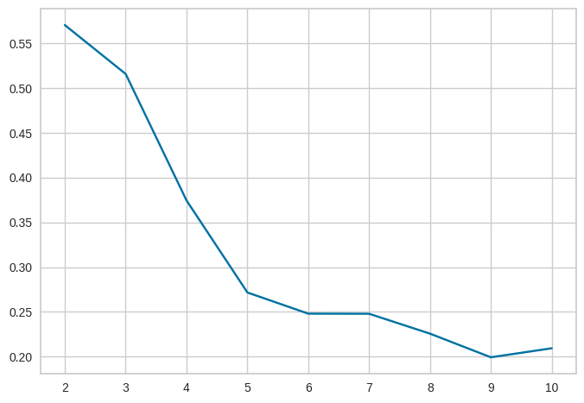
Figure 10: elbow plot

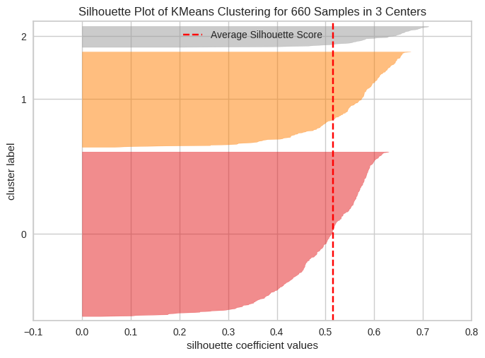
Figure 11: Silhouette plot of K means clustering

Note:
Although silhouette peaked at k=2, we chose k=3 for more interpretable segmentation (low, mid, high customers)

Hierarchical Clustering:

A clustering technique that builds a hierarchy of clusters instead of fixing K upfront (like K-Means).
It produces a tree-like structure called a dendrogram that shows how clusters are merged or split at different levels.

Computing Cophenetic Correlation

The Cophenetic Correlation Coefficient (CCC) is a measure of how faithfully a dendrogram preserves the pairwise distances between the original data points.

Interpretation
- The CCC value ranges between 0 and 1:
  - 0.7 or higher: The dendrogram is a good representation of the data.
  - Closer to 1: The clustering structure is very reliable.
  - Below 0.5: The dendrogram is not a faithful representation

- Highest cophenetic correlation is 0.8977080867389372, which is obtained with Euclidean distance and average linkage.

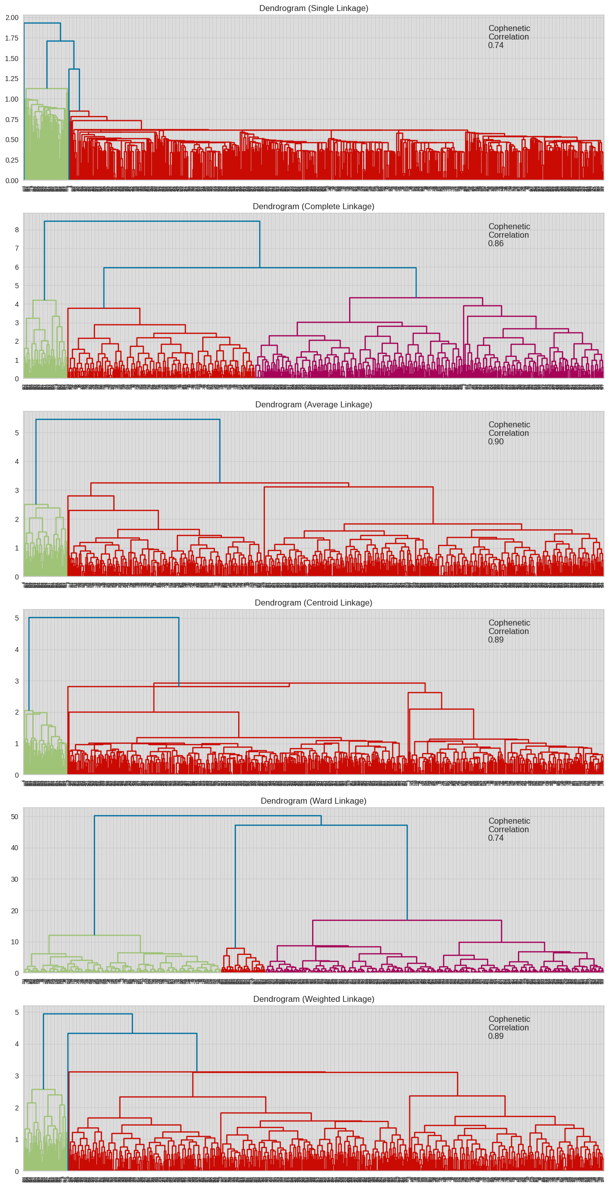
Figure 12: Dendrogram of Various linkages for Cophenetic correlation
Observations
- Looking the the above dendrograms, the ward linkage seems to result in the best separation between clusters, even though its cophenetic correlation is less 0.74 and less compared to the other linkages.
- 3 clusters seems distributing the data in a balanced way.

Cluster Profiling and Comparison - K-means Clustering:

- Cluster Profiling: Describing each cluster by analysing its average feature values.
- The goal is to turn abstract clusters into customer personas that businesses can understand and target.

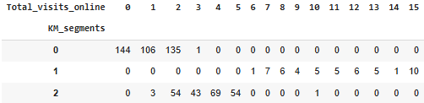
Figure 13: K-means Cluster profiling

Observations
- Cluster 0: Strong skew toward very low online visits (mostly 0 to 2). These users are likely offline customers.
- Cluster 1: Exclusively high online visit counts (6 to 15). These are your digital-first customers, possibly more self-service oriented.
- Cluster 2: A middle ground — users with moderate online activity, peaking around 4 to 5 visits. This segment might represent transitional users who use both services.

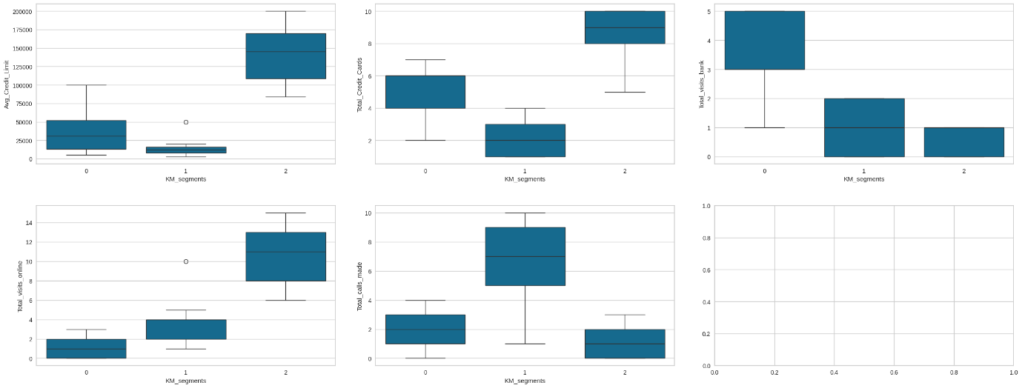
Figure 14: K-means Cluster profiling using boxplots

Insights:
- Segment 0: Mid-level credit users, moderate activity, but high inactive accounts.
- Segment 1: Low credit, few cards, low spending, but relatively high call activity (maybe cost-sensitive customers). Segment 2: High-value customers: high credit limits, more cards, very active, high spending, but low calls/inactivity.

Cluster Profiling: Hierarchical Clustering

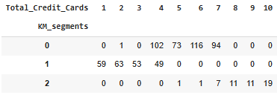
Figure 15: K-means Hierarchical Cluster profiling for total credit cards
Observations
Segment 0 (KM_segments = 0)
- Customers mostly have 4 to 7 credit cards.
- Big concentration at 4, 5, 6 cards (102, 73, 116 respectively).
- This is the mid-level cluster → customers are established but not extreme credit card holders.
Segment 1 (KM_segments = 1)
- Customers mostly have 1 to 4 credit cards.
- Highest counts at 1, 2, 3 cards (59, 63, 53).
- This is the low-credit-card cluster → entry-level or less financially active customers.
Segment 2 (KM_segments = 2)
- Customers mostly have 7–10 credit cards.
- Distribution: 7 (7 customers), 8 (11), 9 (11), 10 (19).
- This is the high-credit-card cluster → heavy/elite users who maintain multiple cards.
- Based on this addressing and pitching to segment 0 and 1 seems more benefecial as they are comparitatively low card holders with high card holders.

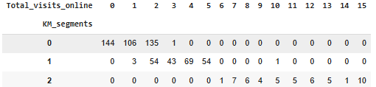
Figure 16: K-means Hierarchical Cluster profiling for total online visits

Observations
- Cluster 0 → Offline/Dormant Online Users (0 to 2 visits).
- Cluster 1 → Moderate Online Users (2 to 5 visits).
- Cluster 2 → Heavy Online Users (6 to 15 visits).
Display with highlight for max value per column:

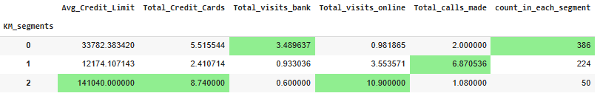
Figure 17: display with highlight for max value per column

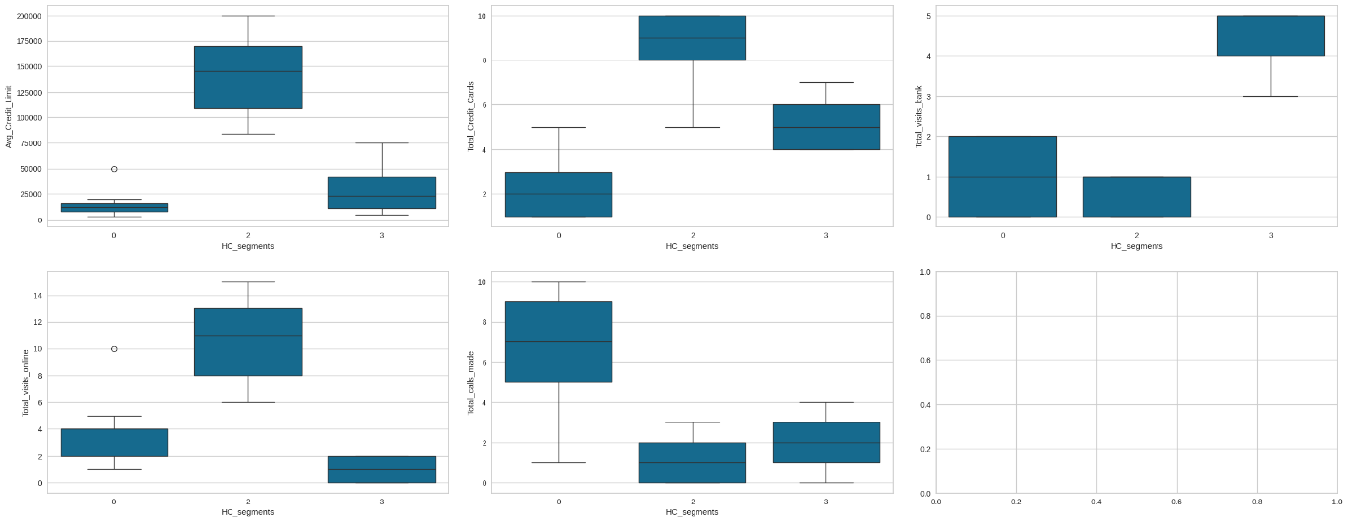
Figure 18: display of max value per column using boxplot
Insights:
Cluster 0 (HC_segment = 0) →
- Very low credit limit
- Few cards (1 to 3)
- Moderate online visits
- High call activity Likely low-value but service-demanding customers.
Cluster 2 (HC_segment = 2) →
- Very high credit limit (~150k)
- Many cards (8 to 10)
- Very low bank visits, very high online visits
- Few calls - Premium digital-savvy customers.
Cluster 3 (HC_segment = 3) →
- Medium credit limit (~40 to 70k)
- Moderate cards (4 to 6)
- High bank visits, very low online usage
- Moderate calls - Traditional branch-visiting customers.

K-means vs Hierarchical Clustering

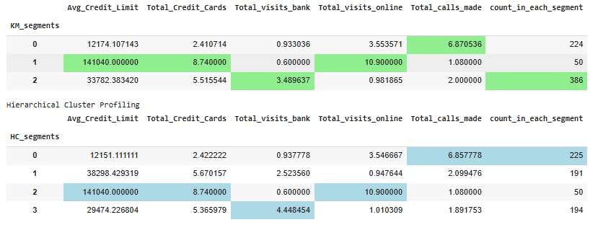
Figure 19: K-means vs Hierarchical Clustering

Observations
- Both models clearly segmented the customers into 3 major clusters: -- Low credit, heavy callers -- High credit, digital users and -- Mid level, offline store visitors

However K means identified only 3 clusters making it simpler.

PCA for Visualization:
- Principal Component Analysis (PCA) is a dimensionality reduction technique.
- It transforms original features (Credit Limit, Cards, Visits, Calls, etc.) into a smaller number of uncorrelated components (PC1, PC2, …).
- These components capture the maximum variance in the data
- PCA reduces features to 2D or 3D, so we can plot customers in a scatterplot.

The first two principal components explain 84.02% of the variance in the data.

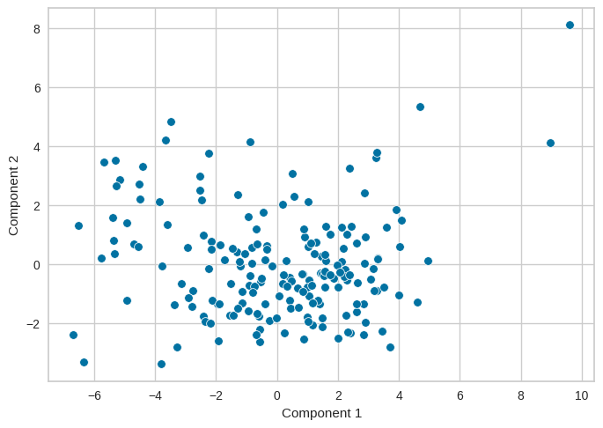

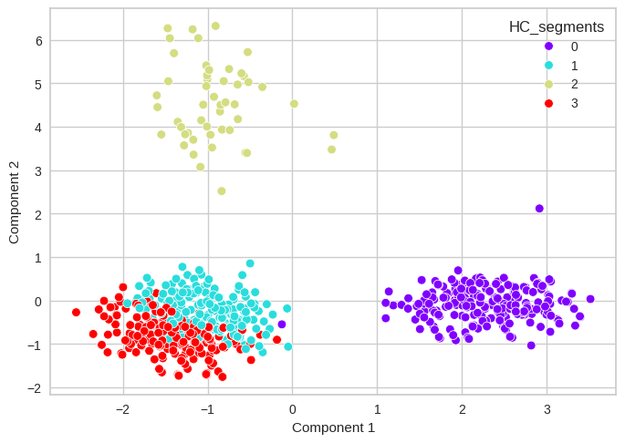
Figure 20: PCA Using scatter plot
Actions and Insights:
- All the clusters are very well seperated.
- Premium digital customers in yellow are more distinct
- Traditional users are closer together as they prefer both online and offline means
- Purple users are low credit and are compact and clearly seperate making them unique.

Final Recommendations:

Segment 1: Low-credit, call-dependent users
- For these segment customers, we need to improve call-center experience aiding in quick resolution and proactive follow-ups.
- We can Offer basic digital training to these customers.
- We can guide and shift some services from calls to app/online.
- We can also try piching some of the low-risk products (e.g., small personal loans, entry-level cards).
Segment 2: Medium-credit, branch-focused users
- Encourage digital usage with special benefits on online platforms and discounts on applications.
- And we can gradually reduce dependency on physical branches by promoting mobile app features.
- Potentially we can increase credit limits and offer higher limit cards.
Segment 3: Premium, digital-savvy users
- We should focus on retaining these high profile customers by various methods.
- We can offer exclusive benefits (airport lounge, coupons or travel discounts).
- We can promote high-value cards to these customers.
- Usually these customers are less demanding hence provide them with personalised services.
Hybrid mid-tier (from HC model)
- These customers use both bank + online moderately.
- Hence they are the best target group for migration to digital with increased incentives.

